**Quiz: Introduction with Animals**

1. Which of the following animals is known for its distinctive black and white stripes?
2. Elephant
3. 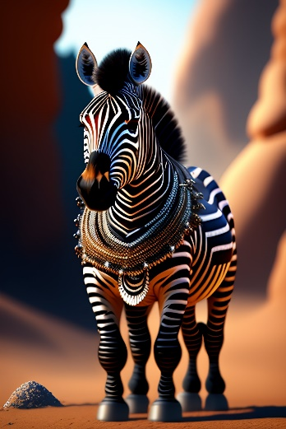Zebra
4. Lion
5. Giraffe

Answer: Zebra

Image Idea:

Display a colorful image of a zebra standing gracefully in the savannah.

Explanation:

The correct answer is Zebra (correct). A zebra is a type of animal that is easily recognizable by its black and white stripes. Elephants, lions, and giraffes do not have this distinctive pattern. Elephants have greyish-brown skin, lions have tawny fur, and giraffes have a unique pattern of patches.

1. Which of the following animals is known for its ability to glide through the air?
2. Penguin
3. 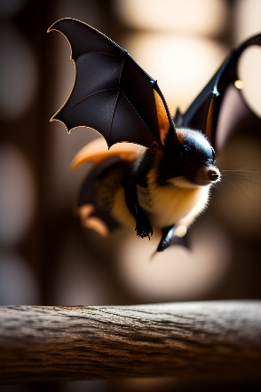Tiger
4. Bat
5. Dolphin

Answer: Bat

Image Idea:

Illustrate an animated image of a bat soaring through the night sky with its wings spread wide.

Explanation:

The correct answer is Bat (correct). Bats are fascinating creatures that can fly and glide through the air using their wings. Penguins, tigers, and dolphins, on the other hand, do not possess this aerial capability. Penguins are flightless birds that swim, tigers are large feline predators that roam on land, and dolphins are marine mammals known for their swimming abilities.

1. Which of the following animals is known for its long neck?
2. Dog
3. Kangaroo
4. Giraffe
5. Monkey

Answer: Giraffe

Image Idea:

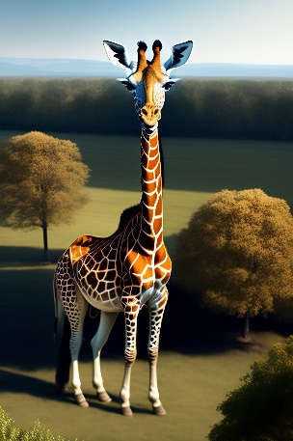Depict a comic image of a giraffe bending its long neck to reach leaves on a tall tree.

Explanation:

The correct answer is Giraffe (correct). Giraffes are famous for their exceptionally long necks, which allow them to reach leaves on trees that other animals cannot access. On the other hand, dogs, kangaroos, and monkeys do not possess this distinctive feature. Dogs have short necks, kangaroos have muscular hind legs for hopping, and monkeys have shorter necks than giraffes.

1. Which of the following animals is known for its ability to change its skin color?
2. Owl
3. Frog
4. Lion
5. Horse

Answer: Frog

Image Idea:

Present a delightful image of a vibrant, camouflaged frog blending into its leafy surroundings.

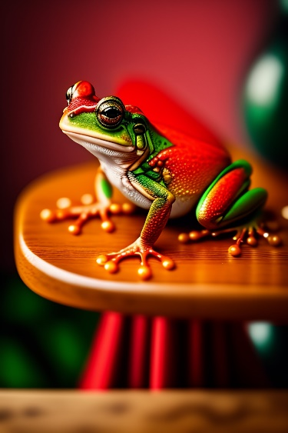

Explanation:

The correct answer is Frog (correct). Frogs can change their skin color to blend in with their environment, which helps them stay hidden from predators or catch prey. Owls, lions, and horses do not possess this unique trait. Owls have distinctive feathers, lions have tawny fur, and horses have a variety of coat colors but cannot change them.

1. Which of the following animals is known for its exceptional jumping skills?
2. Snail
3. Kangaroo
4. Turtle
5. Fish

Answer: Kangaroo

Image Idea:

Illustrate an energetic image of a kangaroo mid-air, showcasing its impressive jumping abilities.

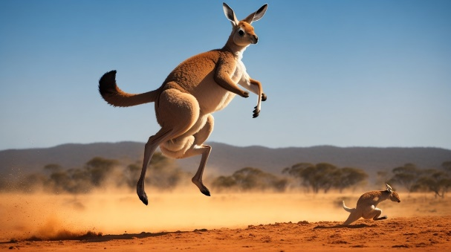

Explanation:

The correct answer is Kangaroo (correct). Kangaroos are renowned for their remarkable jumping skills, using their powerful hind legs to leap great distances. Snails, turtles, and fish do not possess this athletic prowess. Snails move slowly, turtles have a protective shells and crawl, and fish swim gracefully but do not jump like kangaroos.

1. Which of the following animals is known for its ability to swim and balance balls on its nose?
2. Elephant
3. Panda
4. Seal
5. Giraffe

Answer: Seal

Image Idea:

Display an adorable image of a playful seal balancing a colorful ball on its nose.

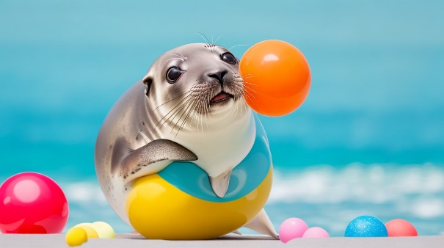

Explanation:

The correct answer is Seal (correct). Seals are known for their aquatic abilities and knack for balancing objects like balls on their noses. Elephants, pandas, and giraffes do not possess this particular skill. Elephants have trunks and are excellent swimmers but do not balance balls on their noses. Pandas are mainly land-dwelling bears, and giraffes are tall animals that do not engage in such behaviors.

1. Which of the following animals is known for its ability to climb trees?
2. Lion
3. Cheetah
4. Monkey
5. Dolphin

Answer: Monkey

Image Idea:

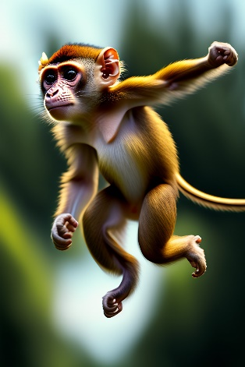Depict an entertaining image of a mischievous monkey swinging through trees with agility.

Explanation:

The correct answer is Monkey (correct). Monkeys are adept climbers and spend significant time in trees, swinging from branches and navigating their arboreal habitats. Lions, cheetahs, and dolphins do not possess this climbing ability. Lions and cheetahs are terrestrial animals that roam on land, and dolphins are marine mammals that swim in water.

1. Which of the following animals is known for its ability to spin a silky web?
2. Elephant
3. Spider
4. Tiger
5. Rhino

Answer: Spider

Image Idea:

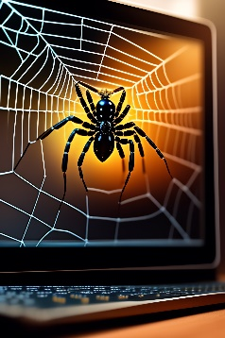Present a fascinating image of a spider delicately weaving its intricate web.

Explanation:

The correct answer is Spider (correct). Spiders are known for their incredible ability to spin intricate webs made of silky threads. Elephants, tigers, and rhinos do not possess this web-spinning skill. Elephants have trunks, tigers are powerful feline predators, and rhinos have tough skin but cannot spin webs.

1. Which of the following animals is known for its ability to camouflage by changing its skin color and texture?
2. Chameleon
3. Lion
4. Hippopotamus
5. Bear

Answer: Chameleon

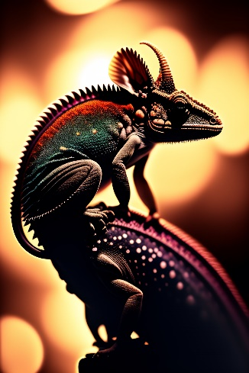Image Idea:

Show an intriguing image of a chameleon blending seamlessly into its environment with its color-changing abilities.

Explanation:

The correct answer is Chameleon (correct). Chameleons are masters of camouflage, capable of changing their skin color and texture to match their surroundings, providing them with excellent hiding abilities. Lions, hippos, and bears do not possess this specific adaptation. Lions have tawny fur, hippos have thick skin, and bears have various coat colors but cannot change them instantly like chameleons.

1. Which of the following animals is known for its ability to hang upside down from tree branches?
2. Cow
3. Monkey
4. Bat
5. Elephant

Answer: Bat

Image Idea:

Illustrate a whimsical image of a Bat hanging upside down from a tree branch, showcasing its unique behavior.

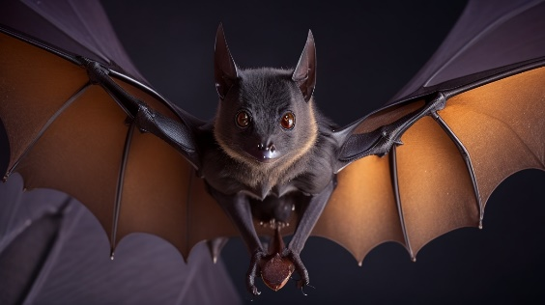

Explanation:

The correct answer is Bat (correct). Bats can hang upside down from tree branches using their feet, which is a distinct characteristic not found in cows, monkeys, or elephants. Cows are large mammals that graze on land, monkeys can climb but do not hang upside down for extended periods, and elephants do not possess the anatomical structure to hang upside down.